PIZZA SALES SQL QUERIES
A. KPI’s
1. Total Revenue:
SELECT SUM (total_price) AS Total_Revenue from pizza_sales
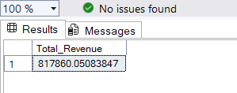
2. Average Order Value
SELECT SUM (total_price) / COUNT (DISTINCT order_id) AS Avg_Order_Value from pizza_sales
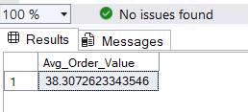
3. Total Pizzas Sold
SELECT SUM (quantity) AS Total_Pizza_Sold from pizza_sales
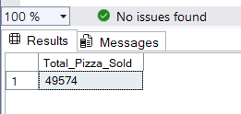
4. Total Orders
SELECT COUNT (DISTINCT order_id) AS Total_Orders from pizza_sales
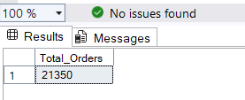
5. Average Pizzas Per Order
SELECT CAST (CAST (SUM (quantity) AS decimal (10,2))/ CAST (COUNT (DISTINCT order_id) AS decimal (10,2)) AS decimal (10,2)) Avg_Pizza_per_order from pizza_sales
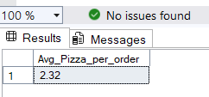
B. Daily Trend for Total Orders

SELECT DATENAME (DW, order_date) as order_day, COUNT (DISTINCT order_id) AS Total_orders
from pizza_sales
GROUP BY DATENAME (DW, order_date)
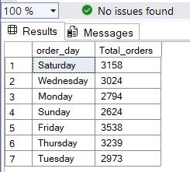
C. Hourly Trend for Orders

SELECT DATEPART (HOUR, order_time) as order_hours, COUNT (DISTINCT order_id) AS Total_orders
from pizza_sales
GROUP BY DATEPART (HOUR, order_time)
ORDER BY DATEPART (HOUR, order_time)
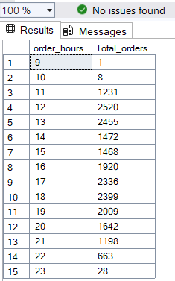

D. % of Sales by Pizza Category
SELECT pizza_category, sum(total_price) as Total_sales, SUM (total_price) * 100 / (SELECT sum(total_price) from pizza_sales) AS PCT
from pizza_sales
GROUP BY pizza_category
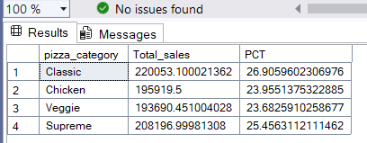
E. % of Sales by Pizza Size
SELECT pizza_size, CAST (sum(total_price) as decimal (10,2)) AS Total_sales, CAST (SUM (total_price) * 100 / (SELECT sum(total_price) from pizza_sales) AS decimal (10,2)) PCT
from pizza_sales
GROUP BY pizza_size
ORDER BY PCT DESC
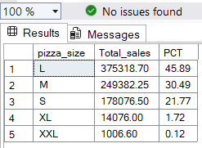
F. Total Pizzas Sold by Pizza Category
SELECT pizza_category, SUM (quantity) AS Total_Pizzas_Sold
from pizza_sales
GROUP BY pizza_category
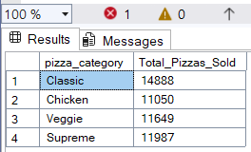

G. Top 5 Best Sellers by Total Pizzas Sold
SELECT TOP 5 pizza_name, SUM (quantity) AS Total_Pizzas_Sold
from pizza_sales
GROUP BY pizza_name
ORDER BY SUM (quantity) DESC
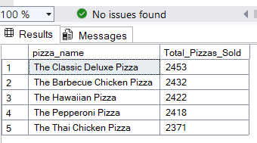
H. Bottom 5 Best Sellers by Total Pizzas Sold
SELECT TOP 5 pizza_name, SUM (quantity) AS Total_Pizzas_Sold
from pizza_sales
GROUP BY pizza_name
ORDER BY SUM (quantity) ASC
